Log in as Finance user

Create a New Account by Selecting Legal Entity

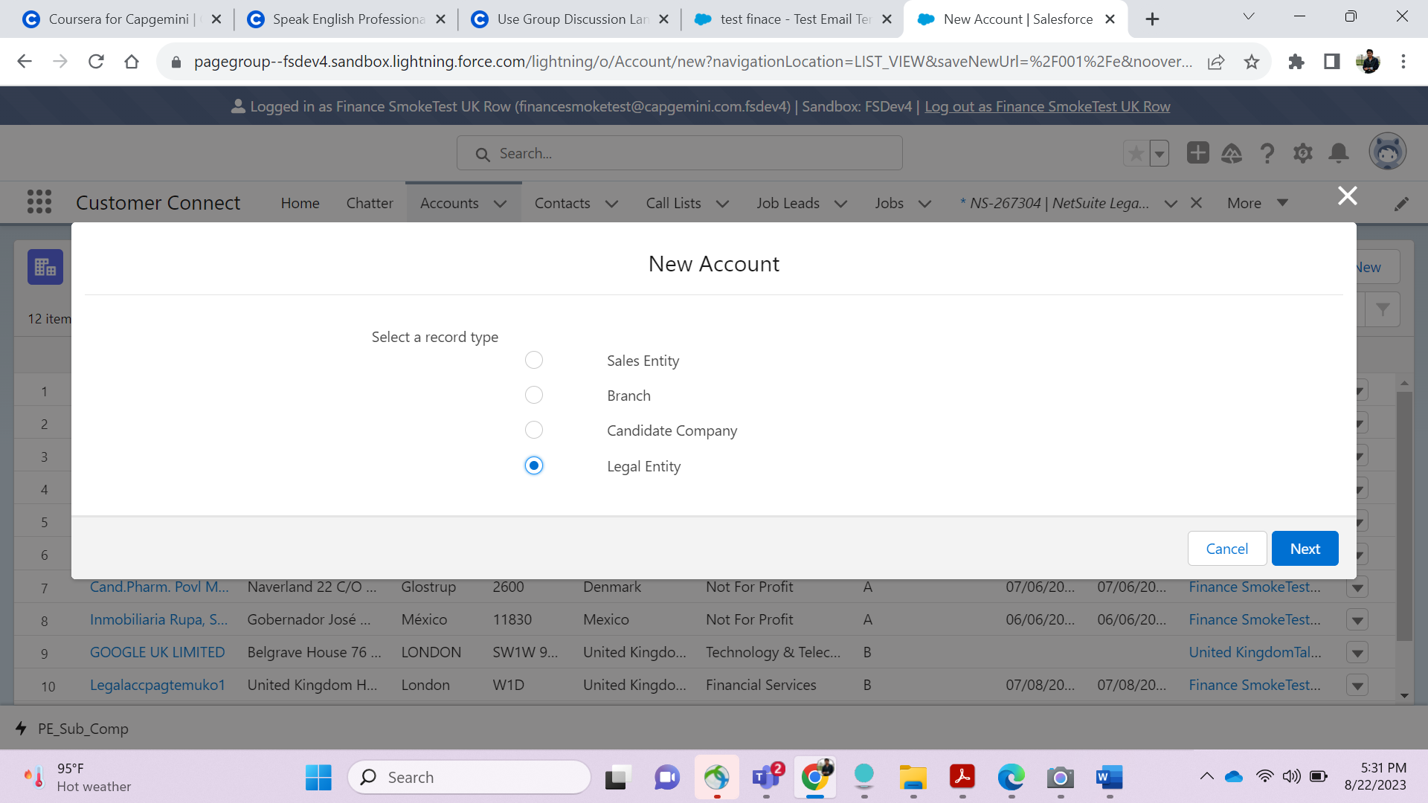

Provide a business Name and press on create New button

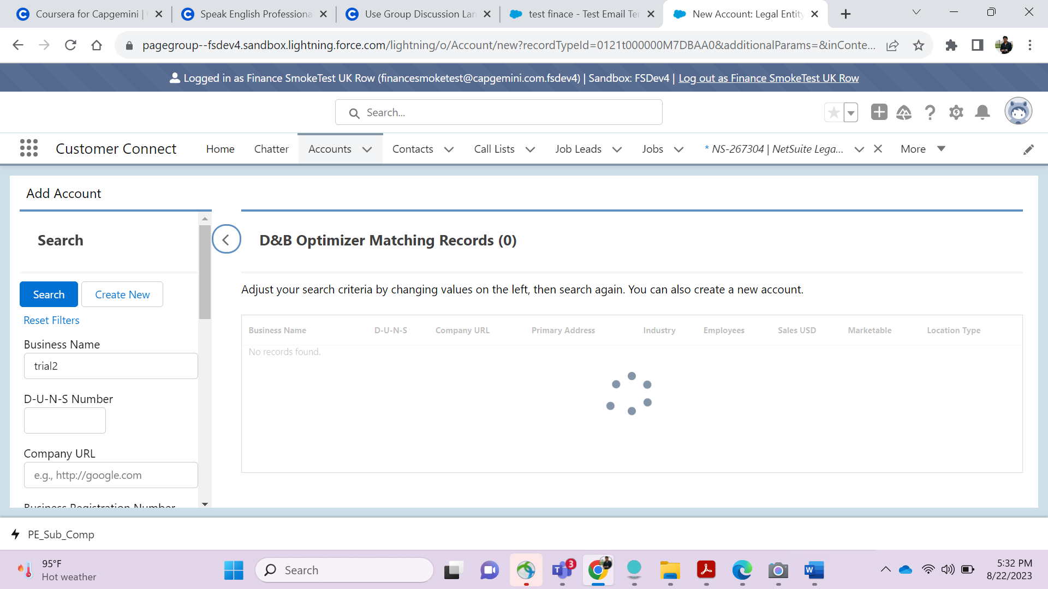

Fill the Account details going to be created

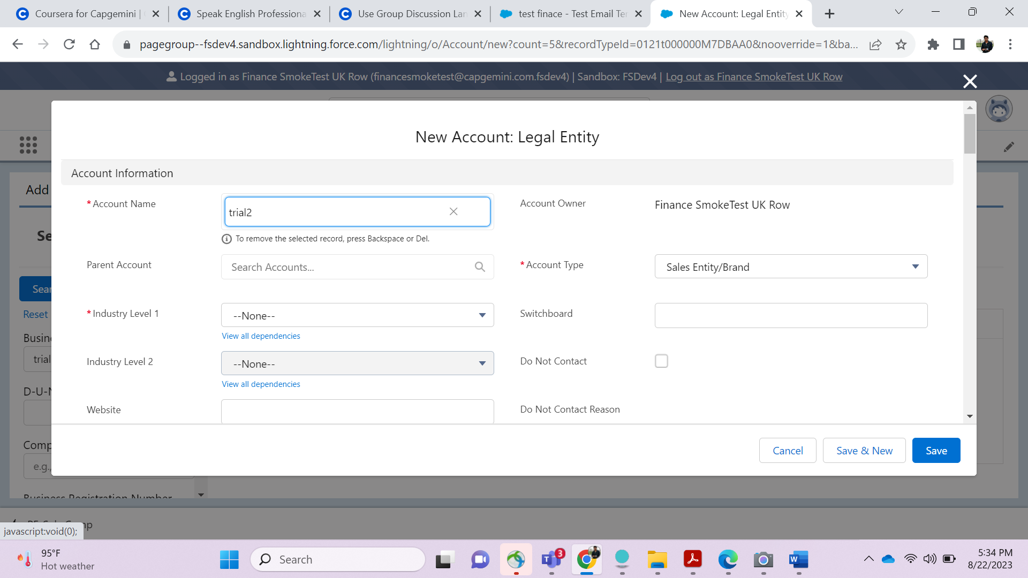

Finally a Account will be created as below

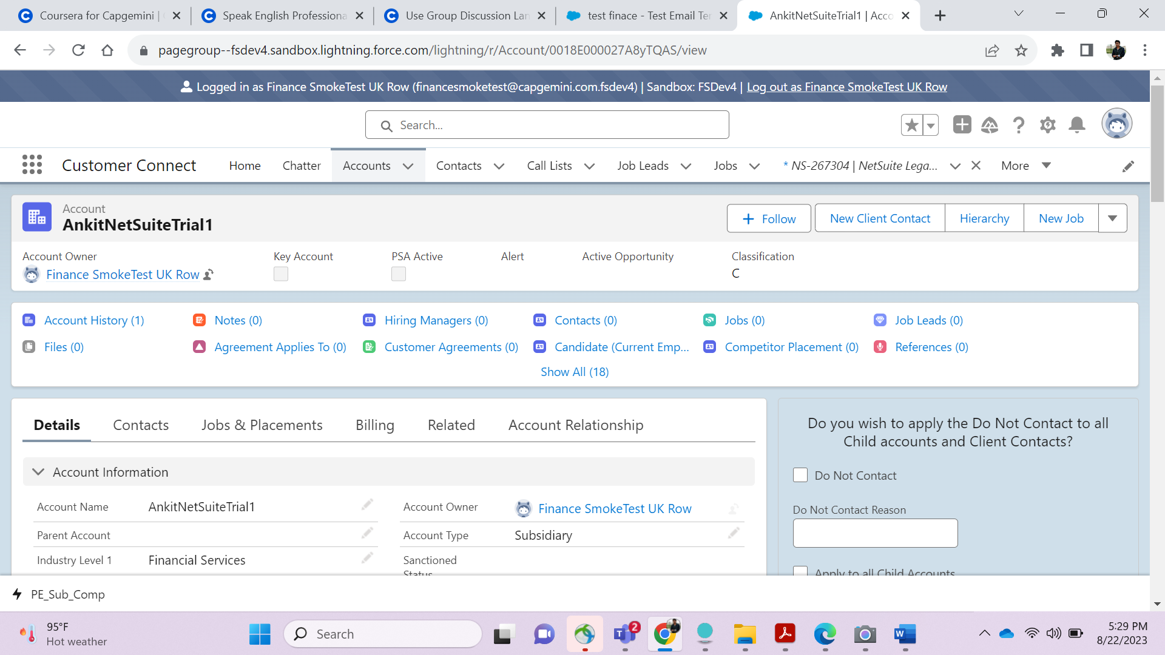

Link of that Created account is pasted here- <https://pagegroup--fsdev4.sandbox.lightning.force.com/lightning/r/Account/0018E000027A8yTQAS/view>

J

Login as United Kingdom Talent Pool Team USERool T

cop

eam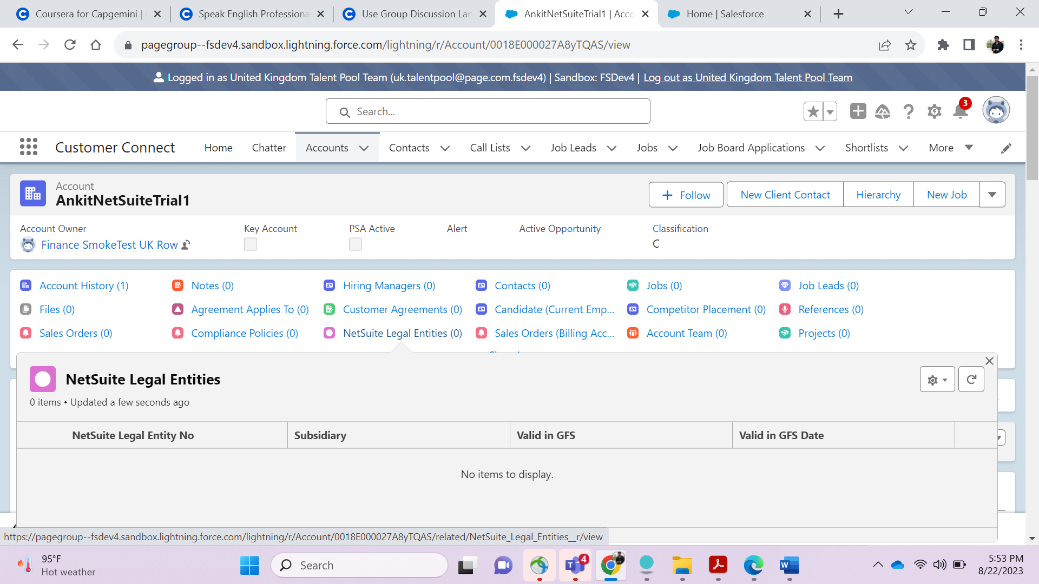

Create a Client (Contact) keep Account name same as AnkitNetSuiteTrial1-

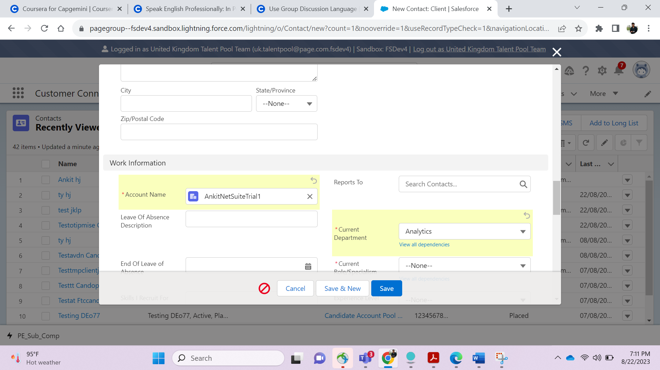

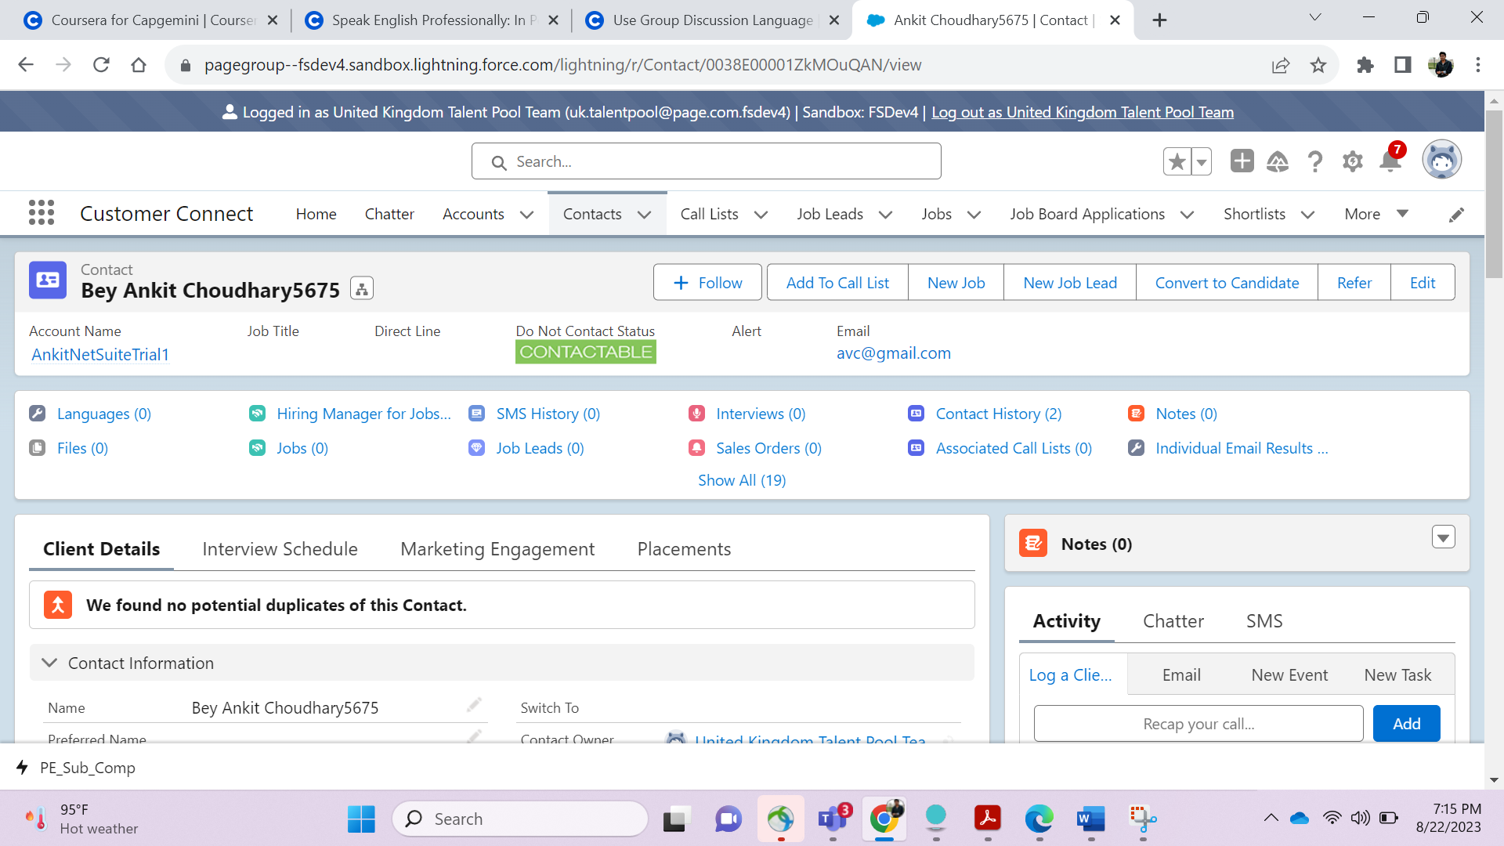

Create A new Permanent Job

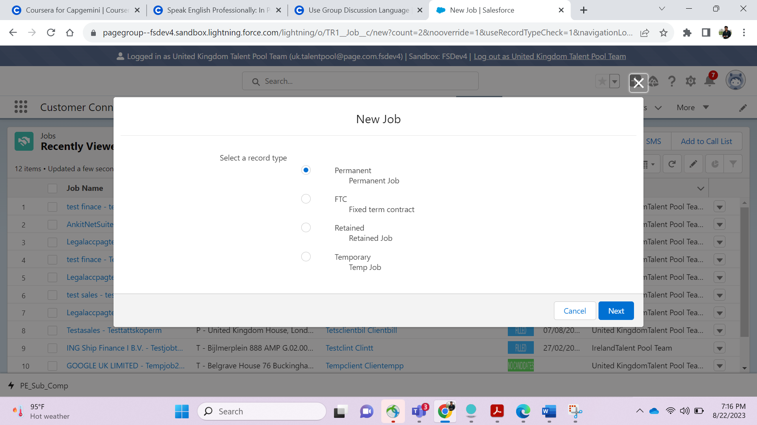

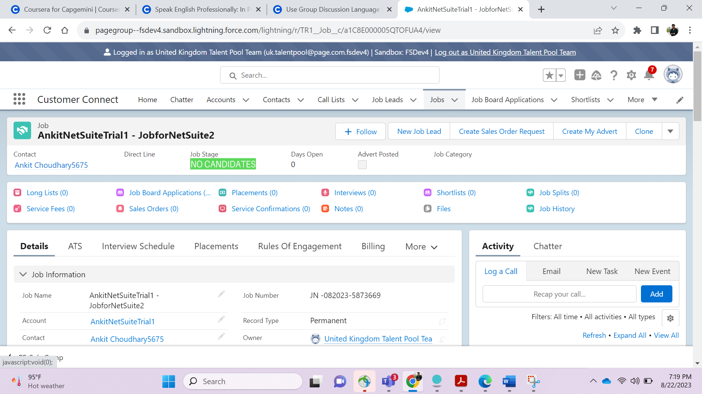

Login as System Admin User in Separate Browser and Subscribe CAP_CC_Create_Legal_Entity__e

And click on PE_Sub_Comp_ at bottom

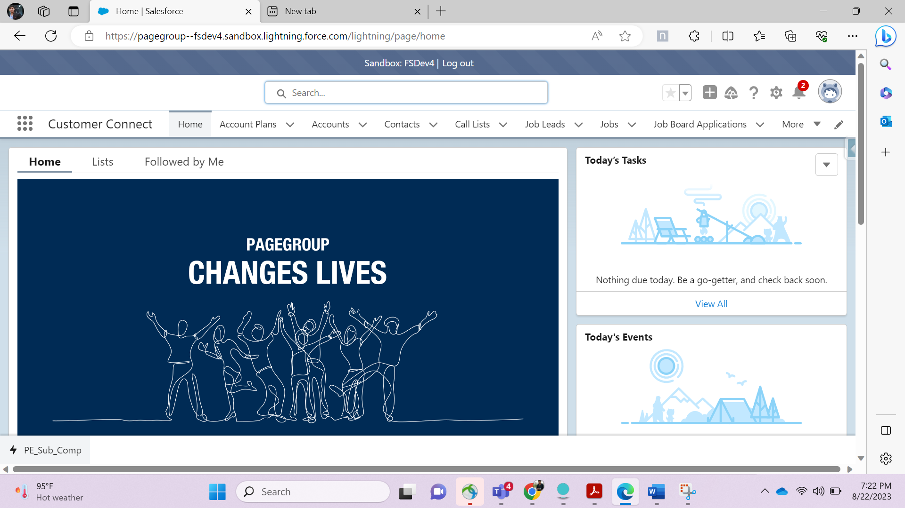

Remove test_e and write as below

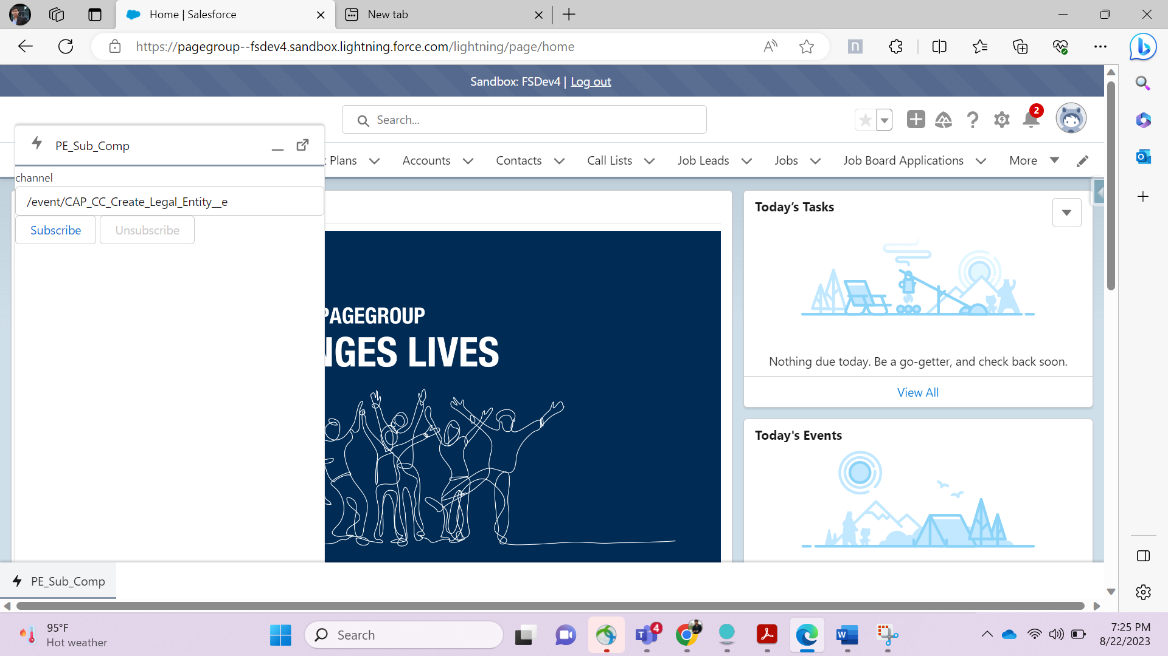

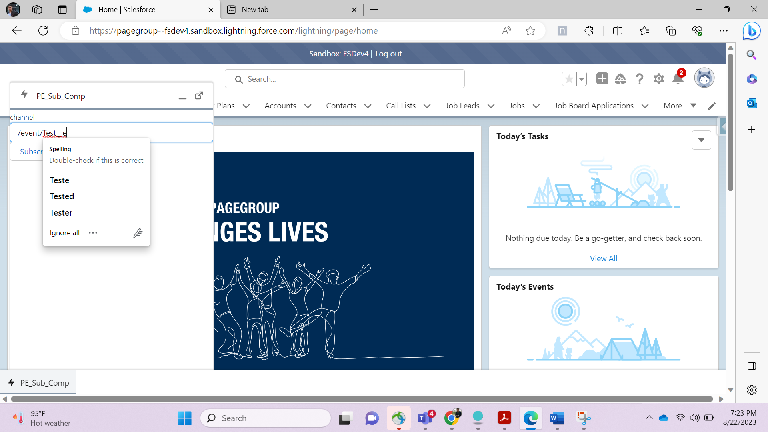

Press ctrl+shift+I to open a console window-

And press on round icon- near top written

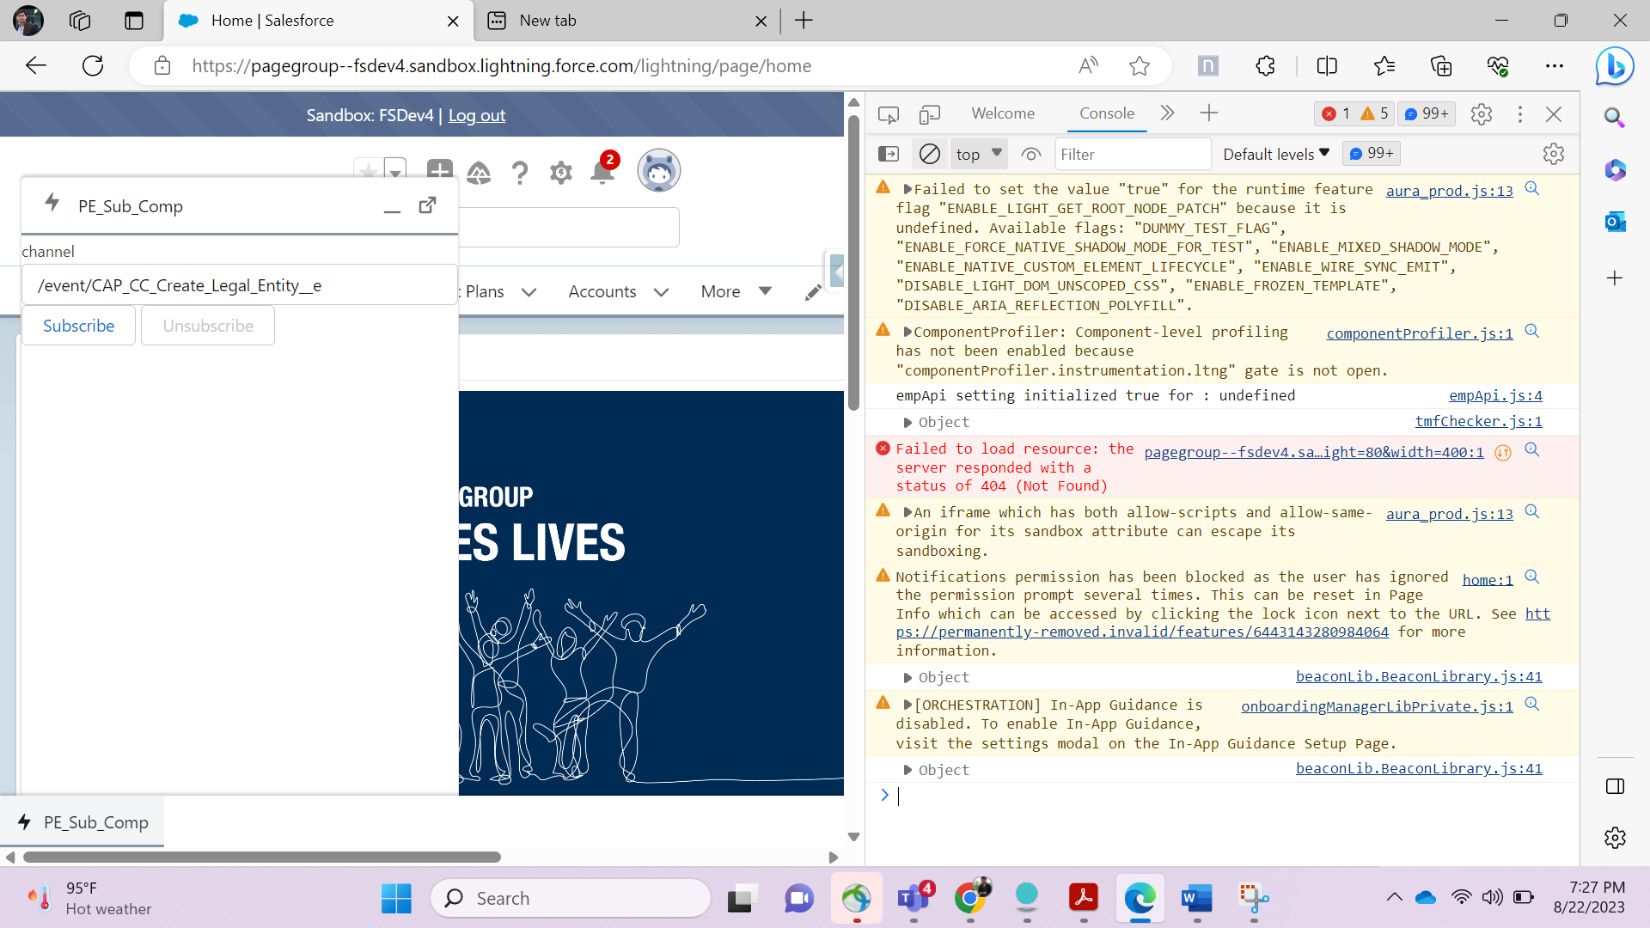

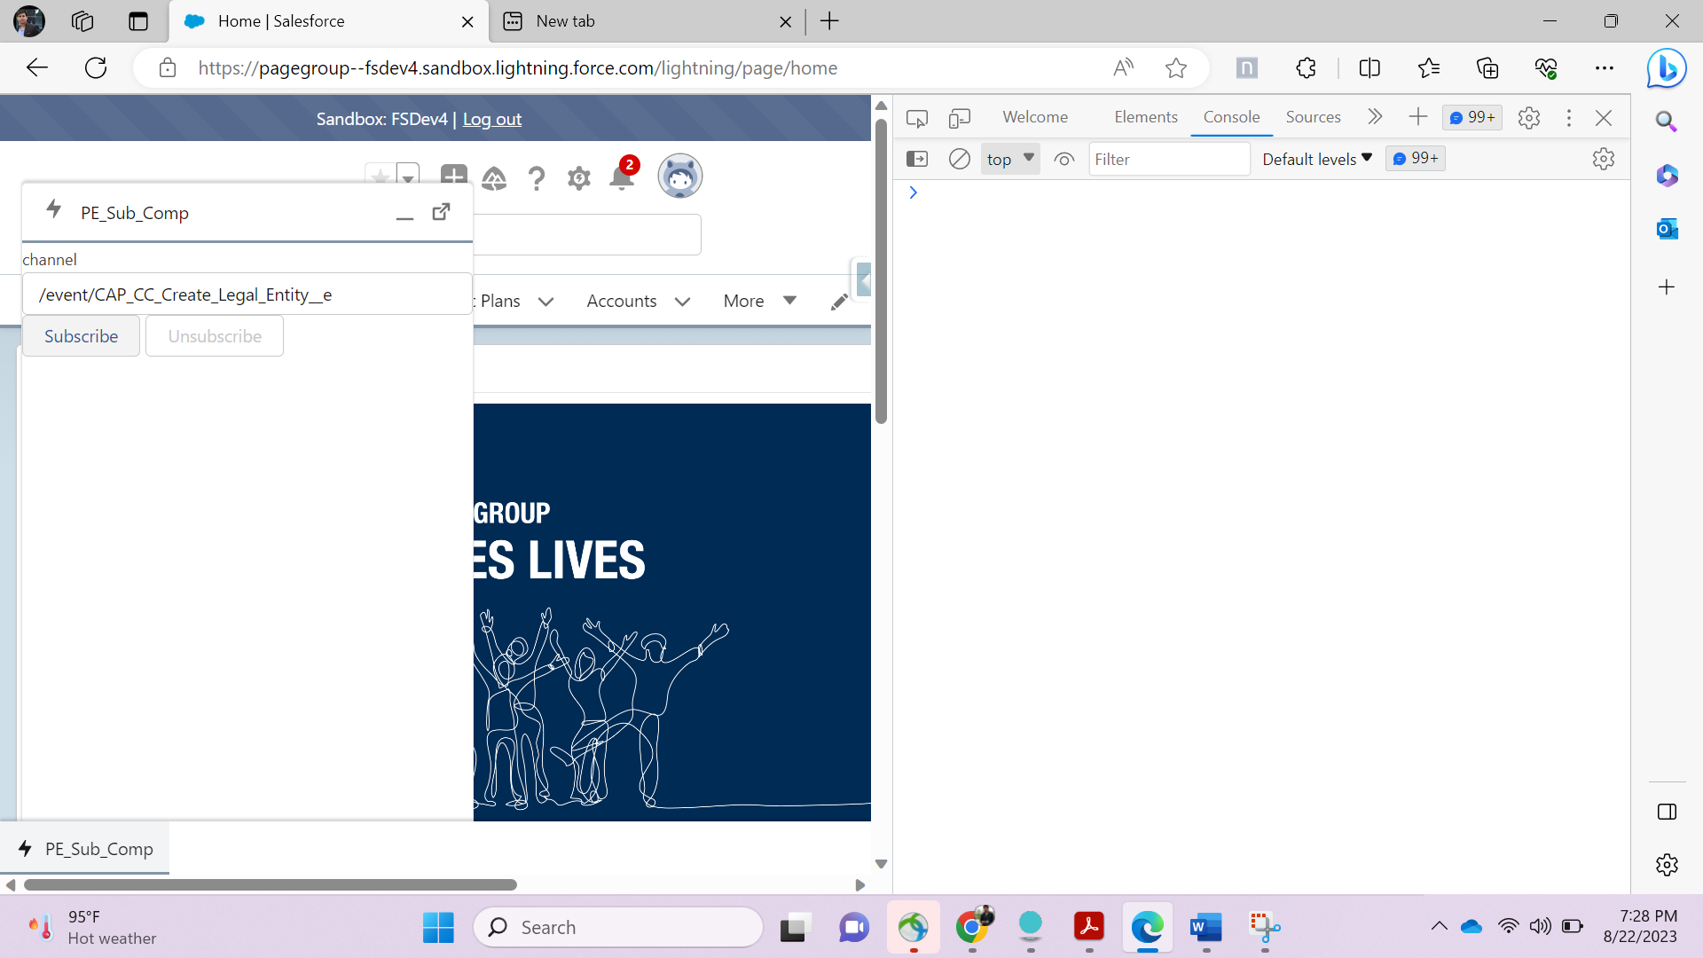

Click On Subscribe to remobe unnecessarily codes.

You will see as below-

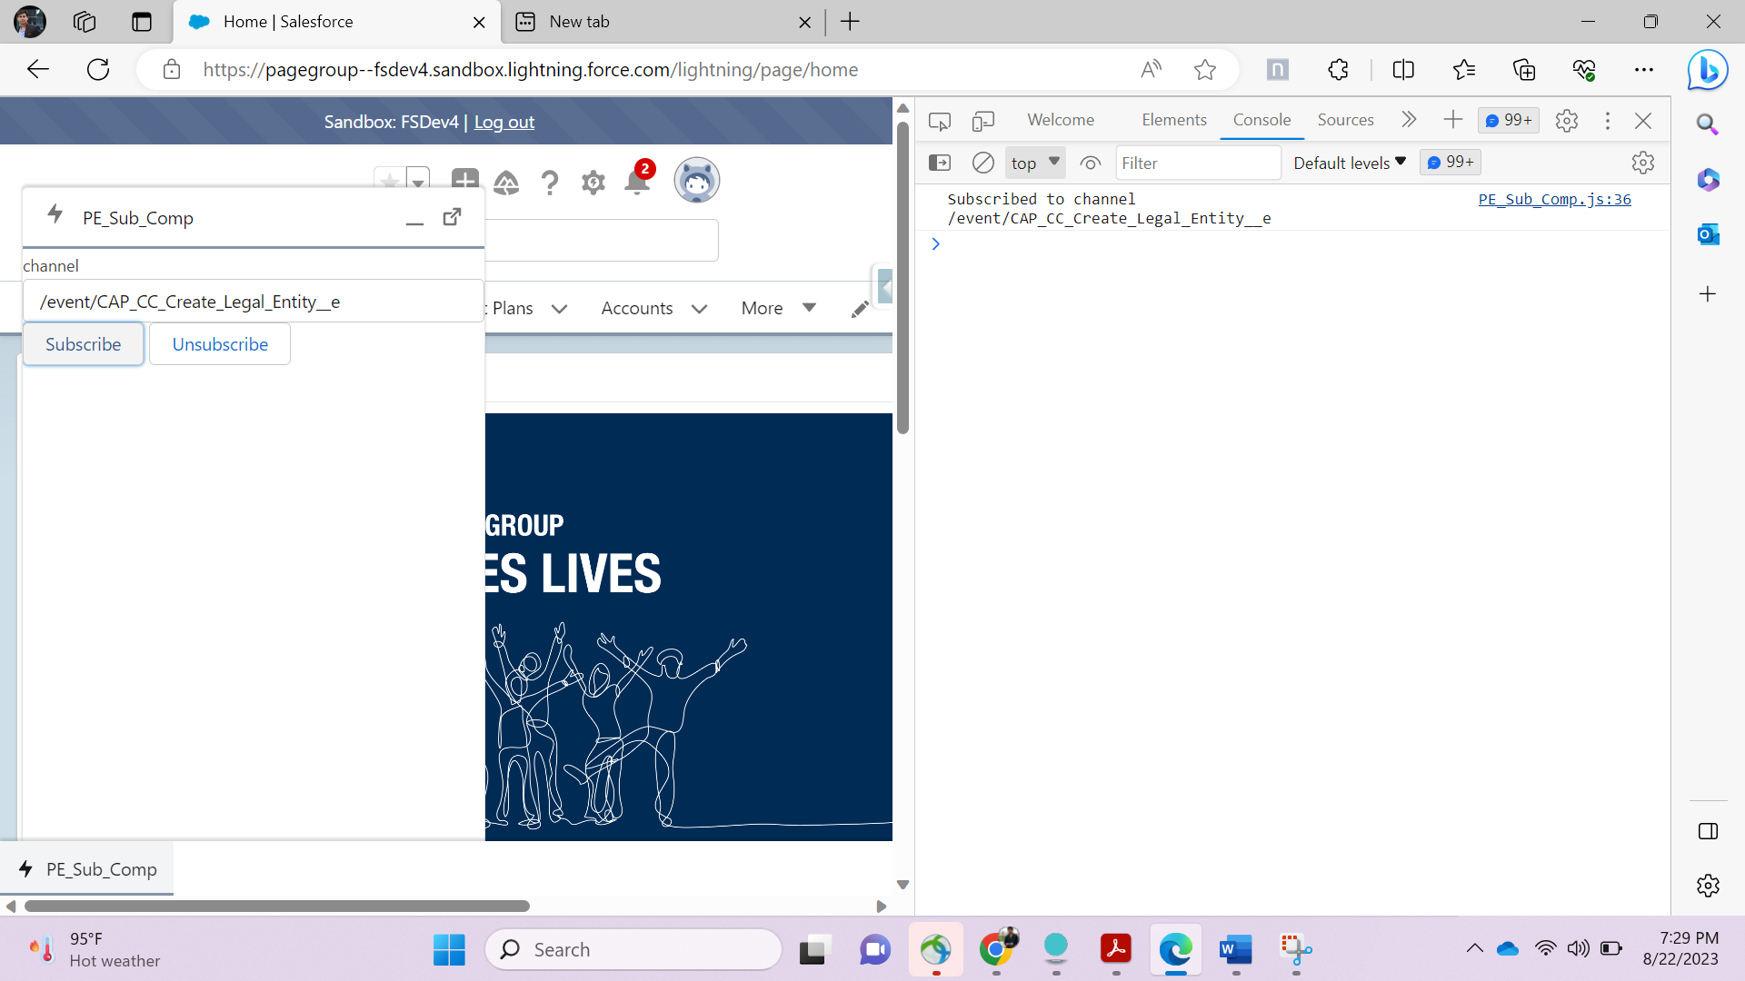

Now switch to chrome browser where user was united kingdom talent user- and click on sales order request button on job then click on yes.

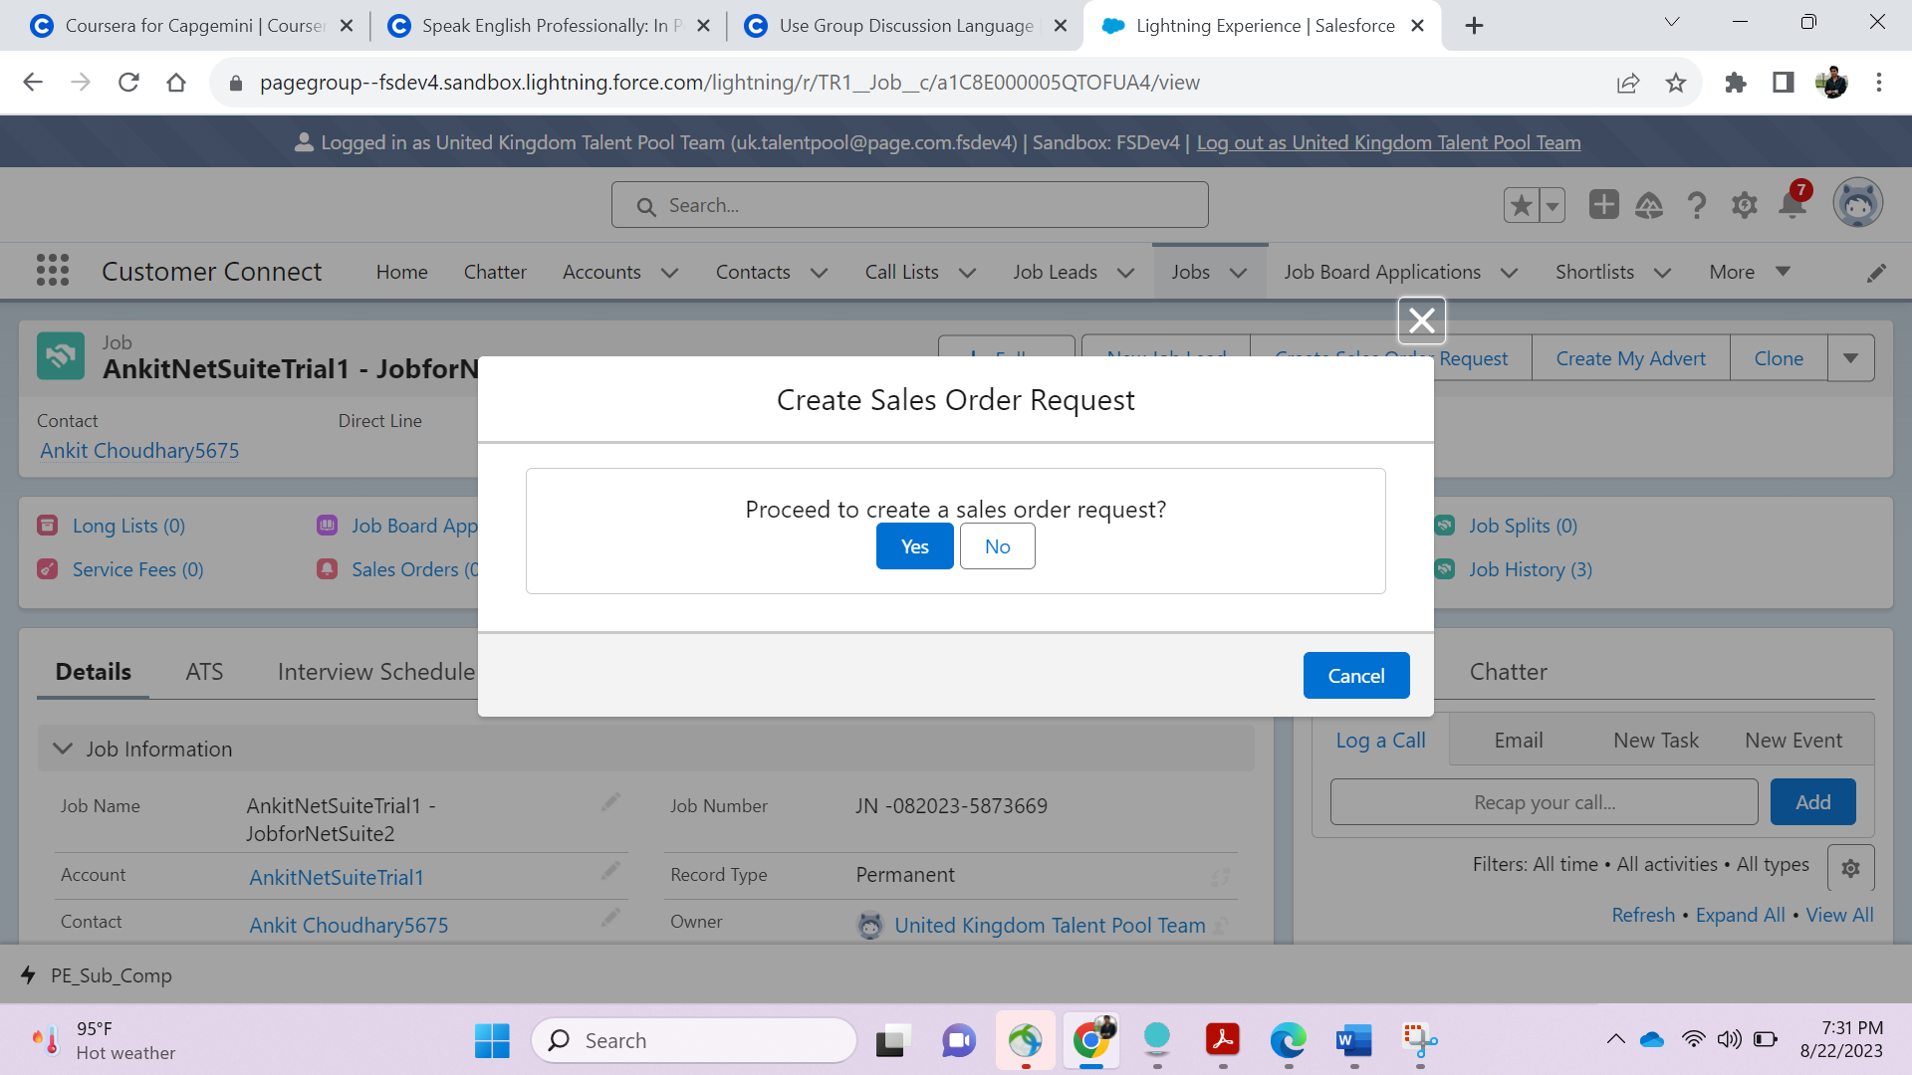

A sales order request is created.

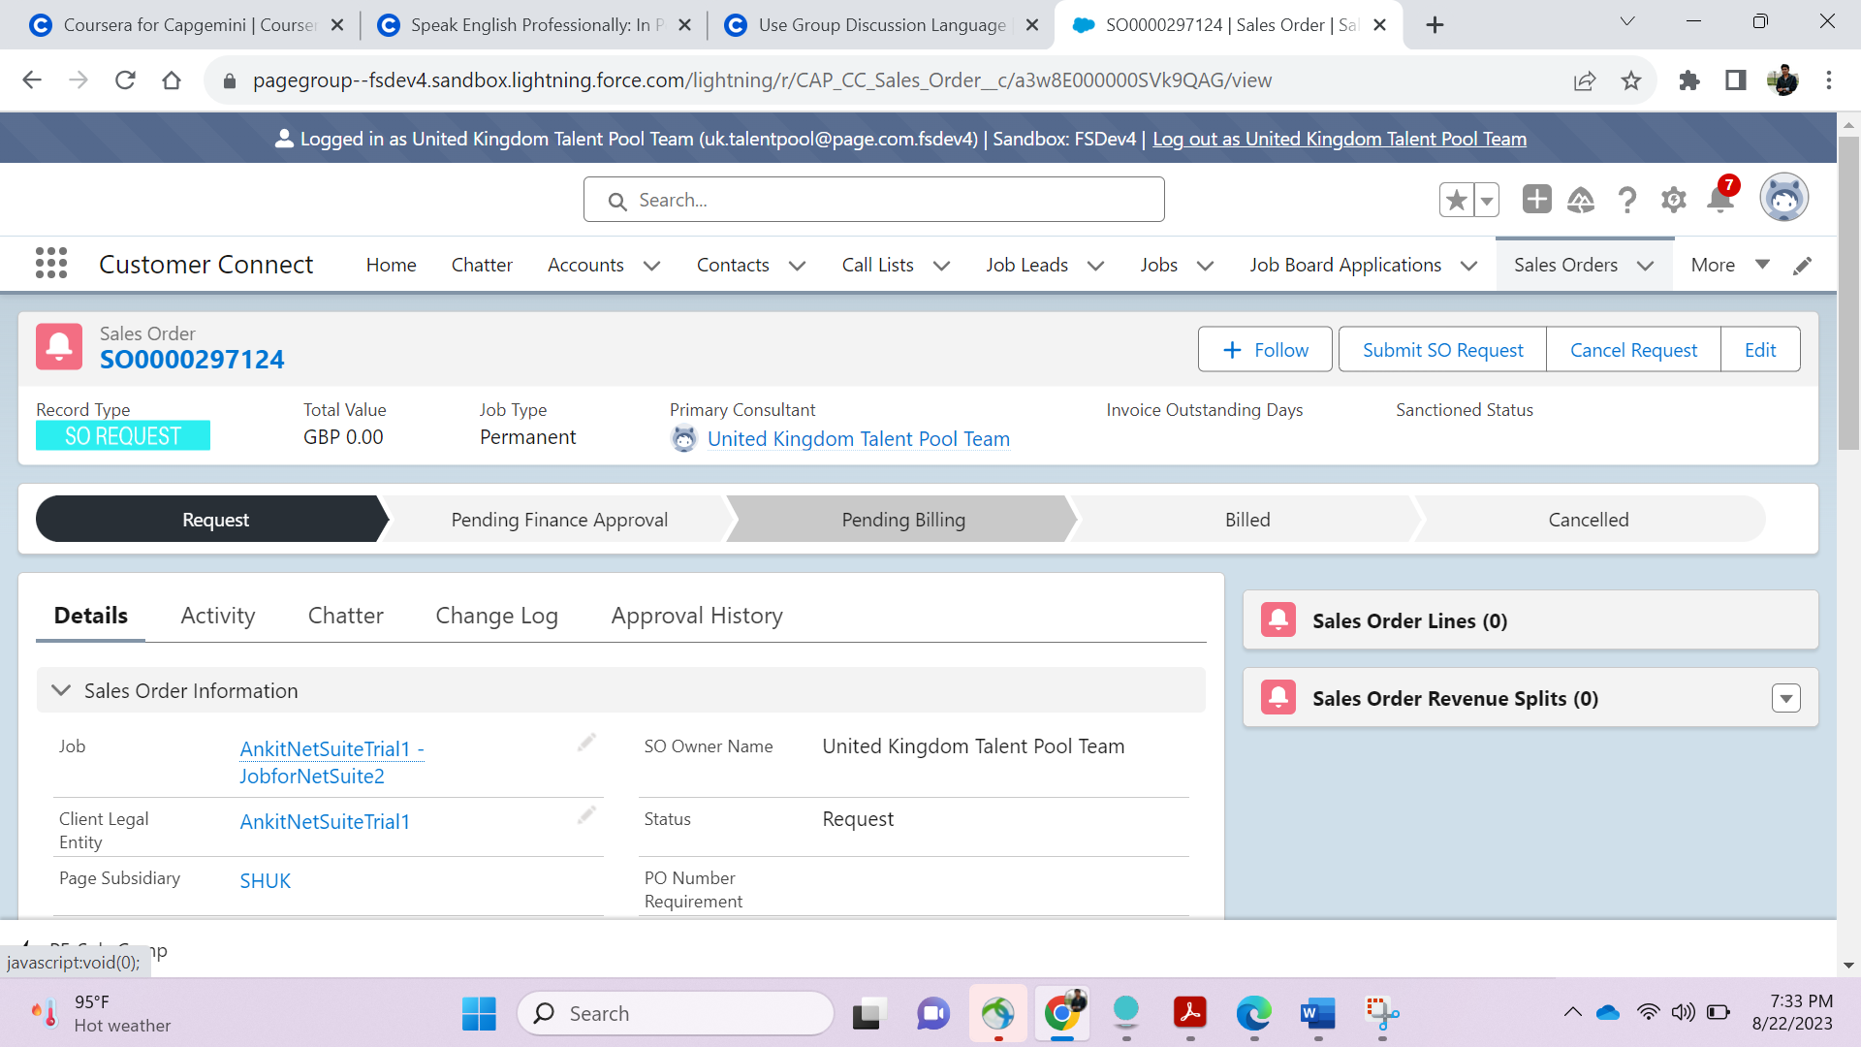

Now Switch to Account to AnkitNetSuite- and Check after clicking on Show All whether subsidiaries created or not ( Net suite legal entity(1))

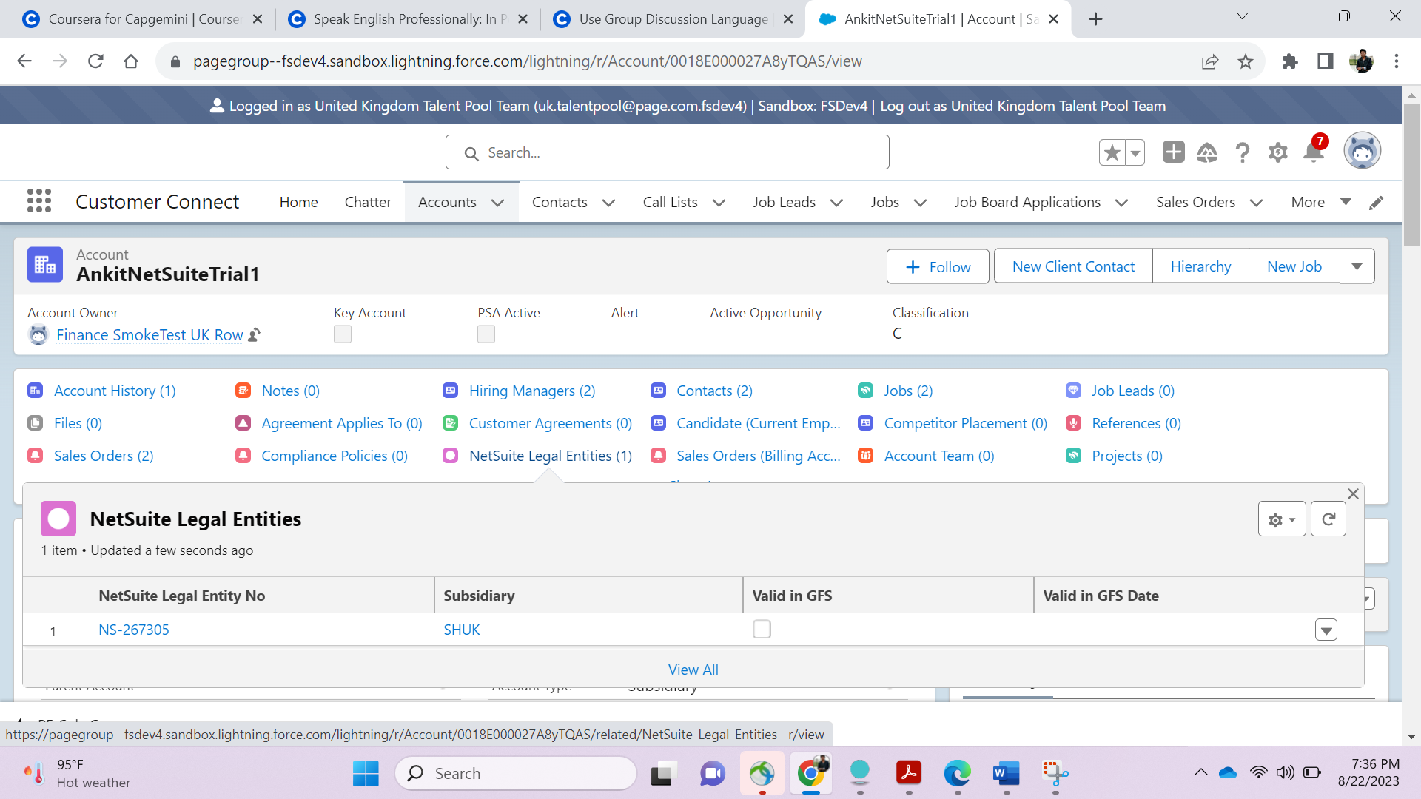

Open this netsuite legal entity through finance user.

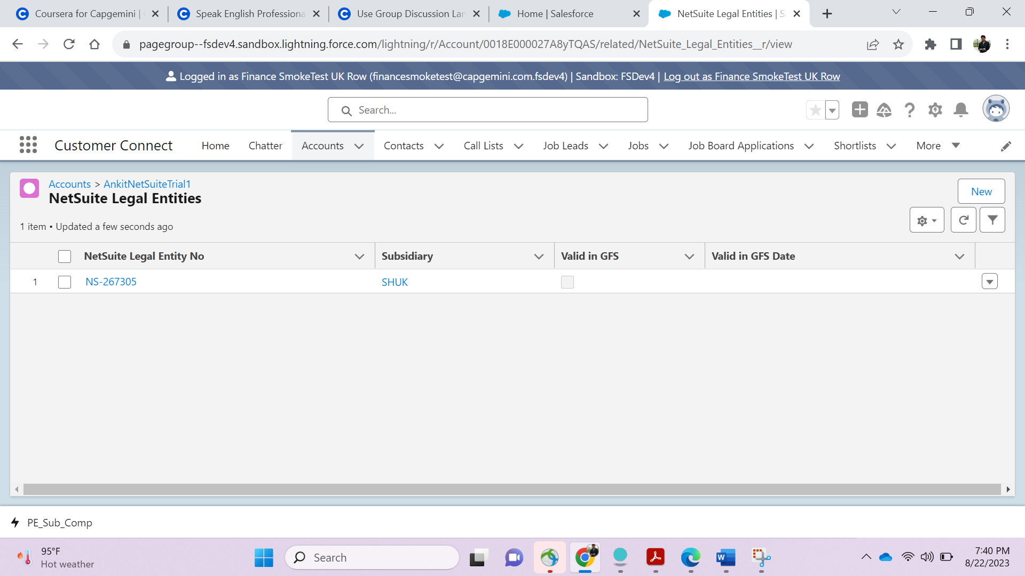

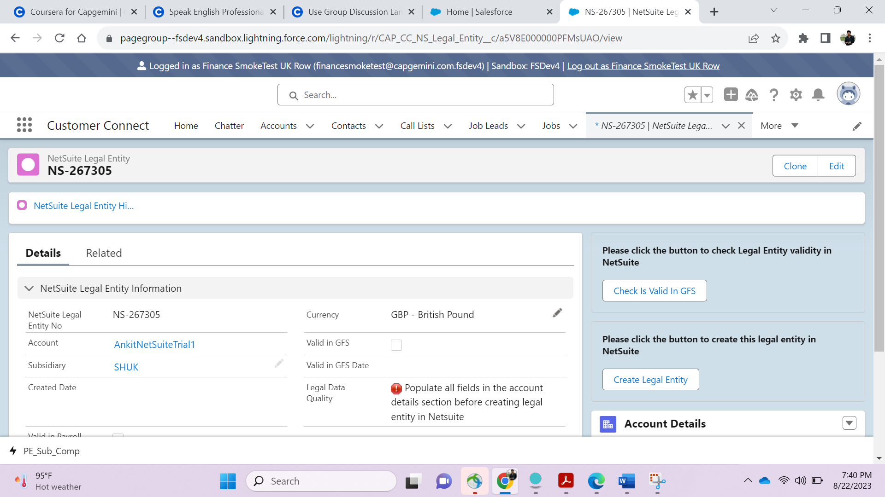

Click on Create Legal Entity-

Then , you will get the datas on the console window of that separate browser having different user as shown below-

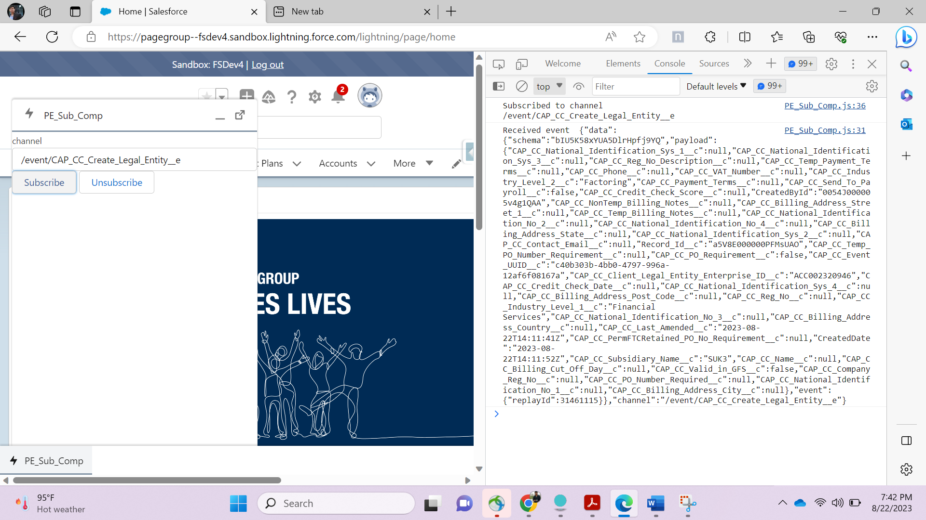

Open duplicate tab on edge browser having console and search platform event Logs in App Launcher-

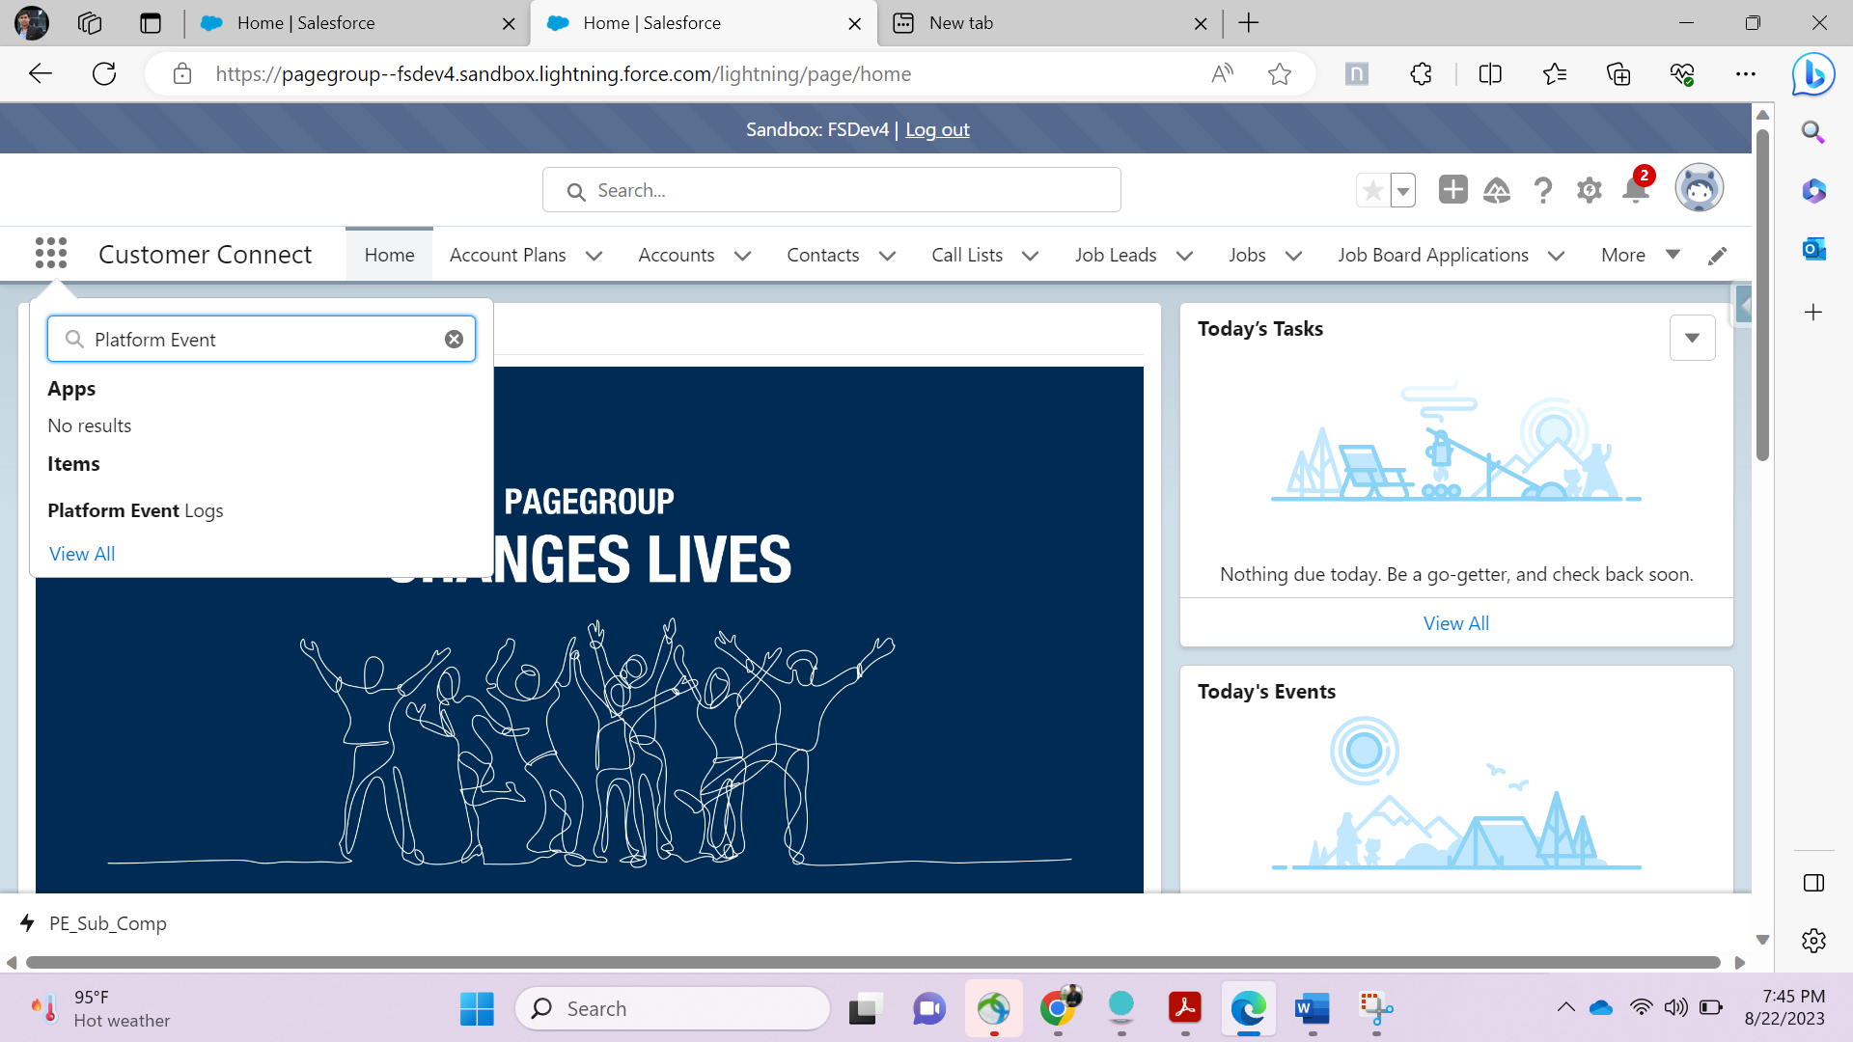

Open Click legal entity platform event ( This name you provided in PE_Sub_Comp_)

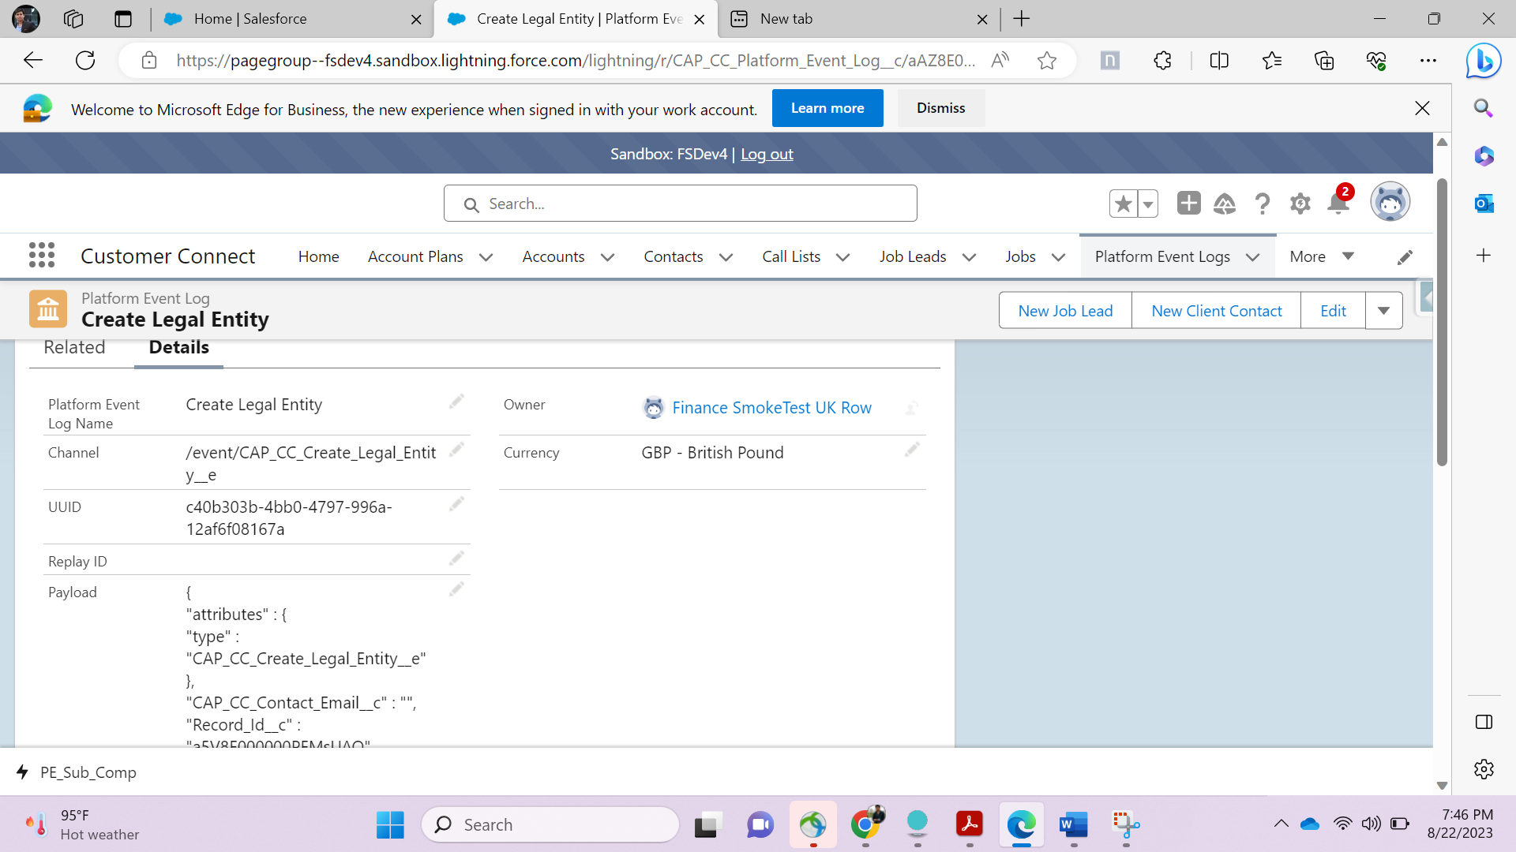

Below s.shot is for reference for name of platform event (Create Legal Entity)

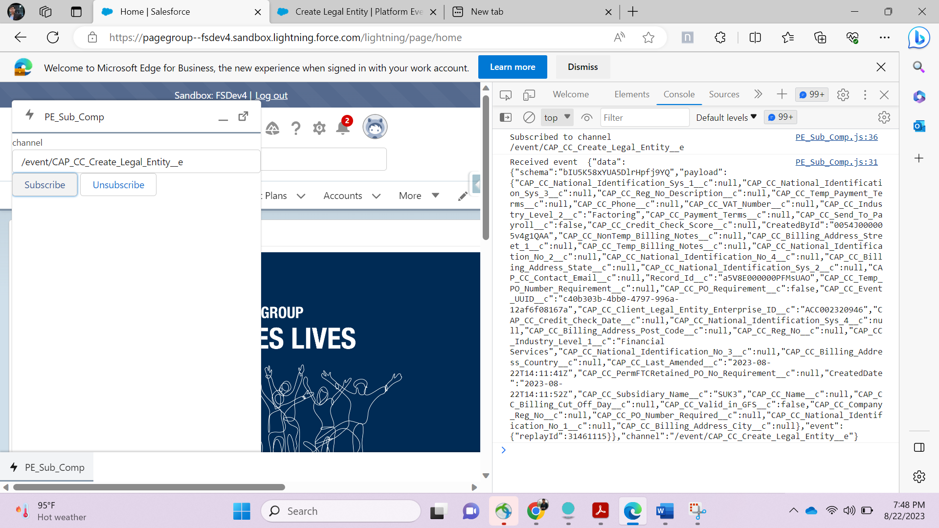

Click on - Check is Valid in GFS button

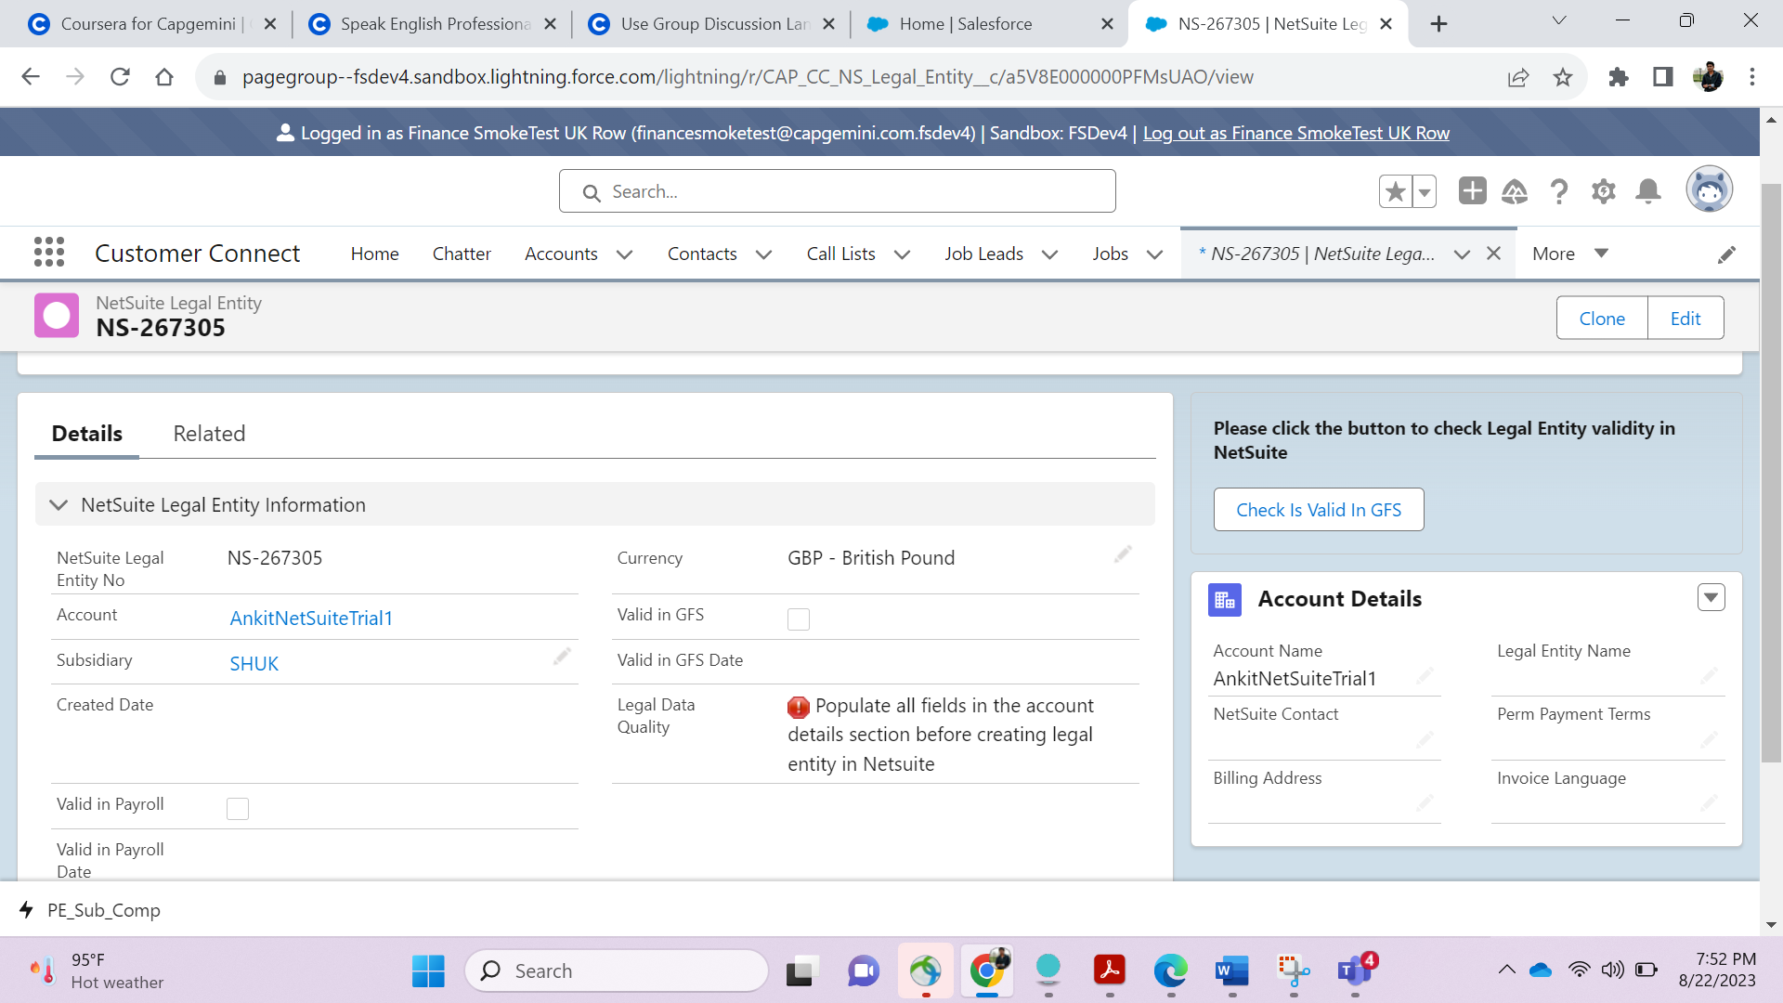

You will get a new subscribe popup everytime as shown below-

